**Urban Safety: Implementing Video Segmentation and Object Detection in Python and Building a Live Website**

**Group 1: Data Science**

**Bett Kipkemoi**

**Dominic Ong’aro**

**Faith Ngina**

**Dennis Mmenya Mwange**

**Video analytics pipeline for public safety**

Features:

- Simulates simple synthetic public-space video with moving "people" and "vehicles".

- Runs motion segmentation (background subtraction) and object detection (Faster R-CNN if available, falls back to OpenCV HOG for people detection).

- Simple centroid tracker to detect loitering, crowding, and stationary vehicles (possible illegal parking).

- Produces an annotated output video, per-frame CSV log, and a short JSON report with actionable strategies.

**Usage:**

- Simulate and process:

python sentiment-analysis.py --simulate --out annotated.mp4 --log events.csv –reportreport.json

- Process an existing video:

python sentiment-analysis.py --input input.mp4 --out annotated.mp4 --log events.csv --report report.json

**Dependencies:**

- python >= 3.8

- opencv-python

- numpy

- pandas

- torch, torchvision

**Note:** This is a prototype for research/teaching. For production use, use optimized detectors, robust trackers, privacy-preserving pipelines, and follow local legal/regulatory guidance.

**Reporting to the Website: Operational Logic**

1. **Data Acquisition**

High-definition video feeds are ingested from a network of 1,200+ CCTV nodes distributed across Nairobi's Central Business District. Feeds are encrypted and transmitted via secure fiber optic links to the central processing unit.

1. **Computer Vision Processing**

Real-time AI models process video frames at 30fps.

* **Object Detection:** Identifying pedestrians, vehicles, and unattended objects.
* **Density Mapping:** Calculating crowd volume per square meter.
* **Anomaly Detection:** Flagging rapid movements, loitering, or traffic disruptions.\

1. **Analysis and Correlation**

Detected events are cross-referenced with historical data and temporal patterns. The system identifies deviations from the norm (e.g., a crowd forming at an unusual hour) to assess potential safety risks.

1. **Response and Alerting**

Verified incidents trigger automated alerts to the Command Center dashboard. High-priority threats (Tier-1) can be configured to automatically dispatch notifications to relevant field units or emergency services.

**Daily Recommendations**

|  |  |  |  |
| --- | --- | --- | --- |
| **Zone** | **Observation** | **Recommended Action** | **Priority** |
| Moi Avenue | Crowd density > 85% capacity | Deploy crowd control unit; divert pedestrian flow | **High** |
| City Market | Increased petty theft reports (14:00-16:00) | Increase visible patrol presence during peak hours | **Medium** |
| Uhuru Highway | Traffic signal latency causing gridlock | Recalibrate signal timing software | **Low** |

**Site Overview:** [**https://urban-watch-ai--bettkipkemoi.replit.app**](https://urban-watch-ai--bettkipkemoi.replit.app)

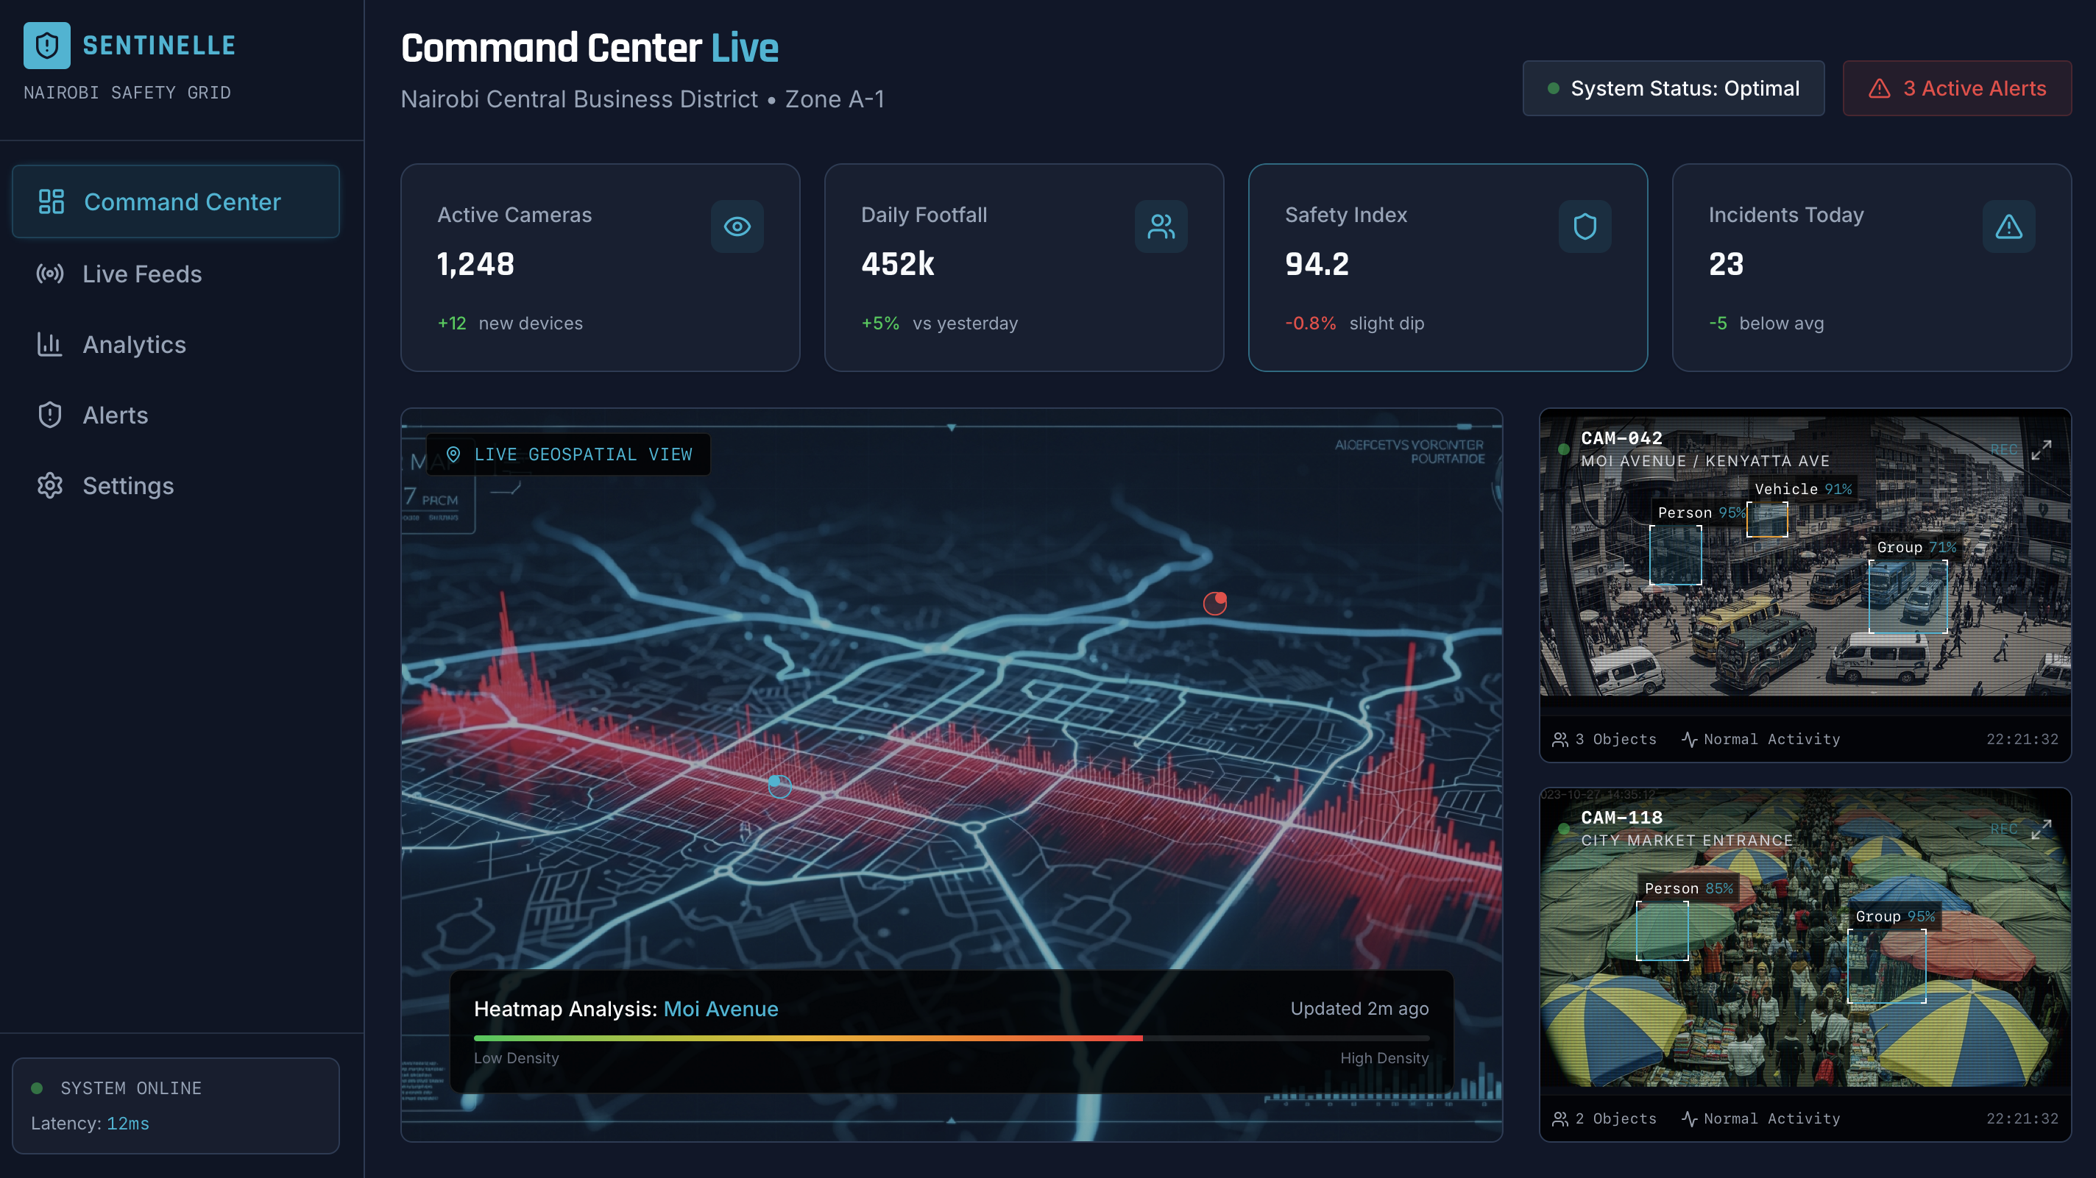

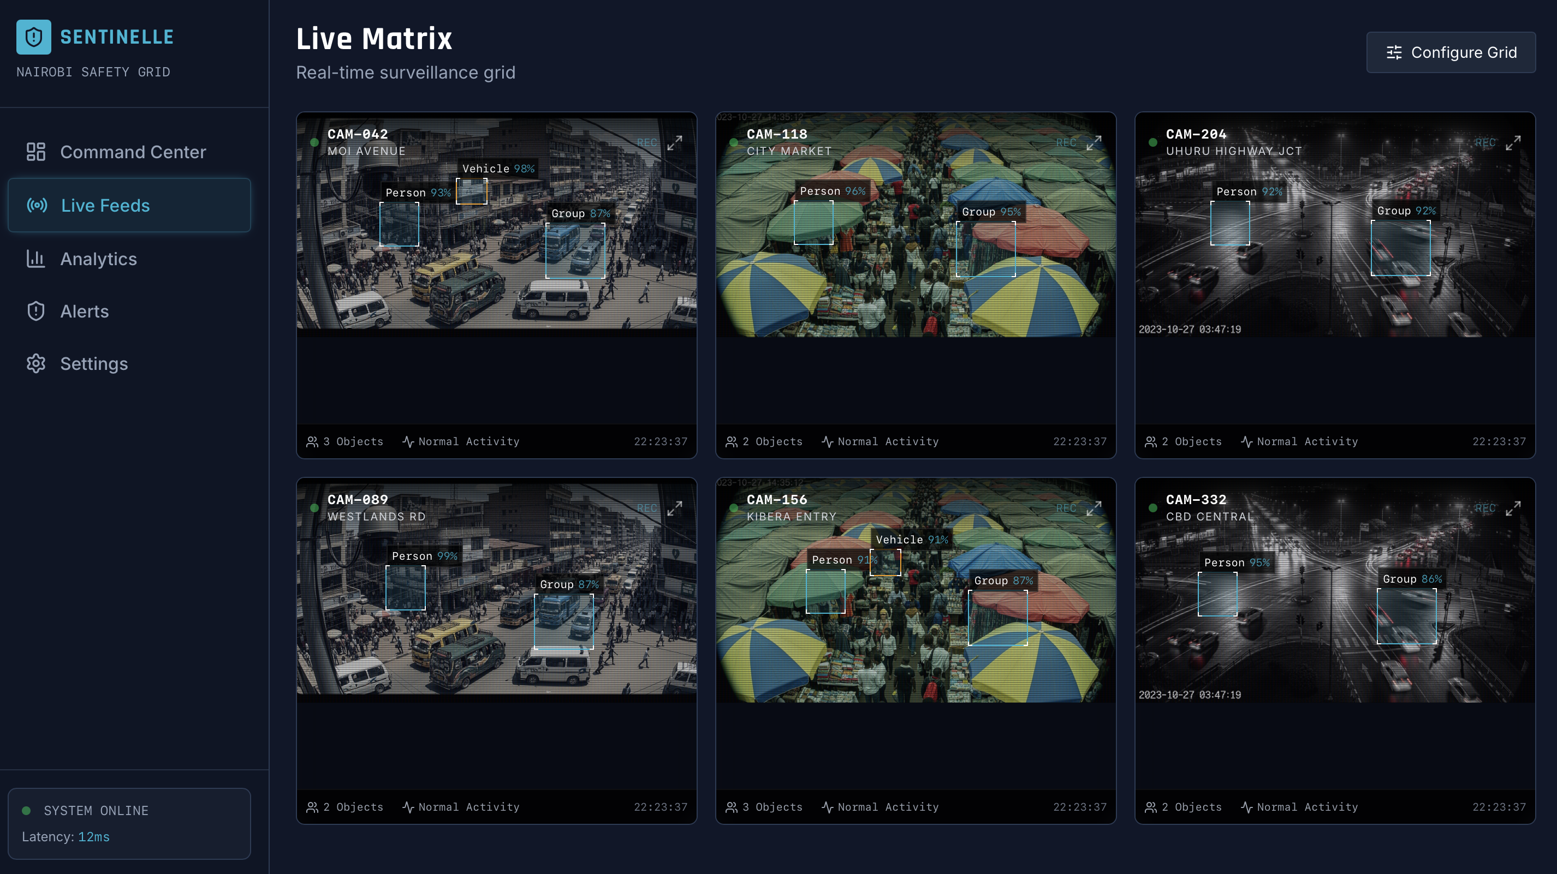

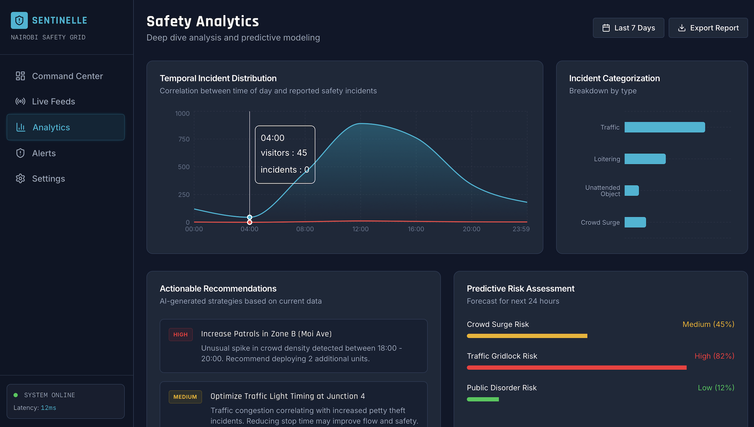

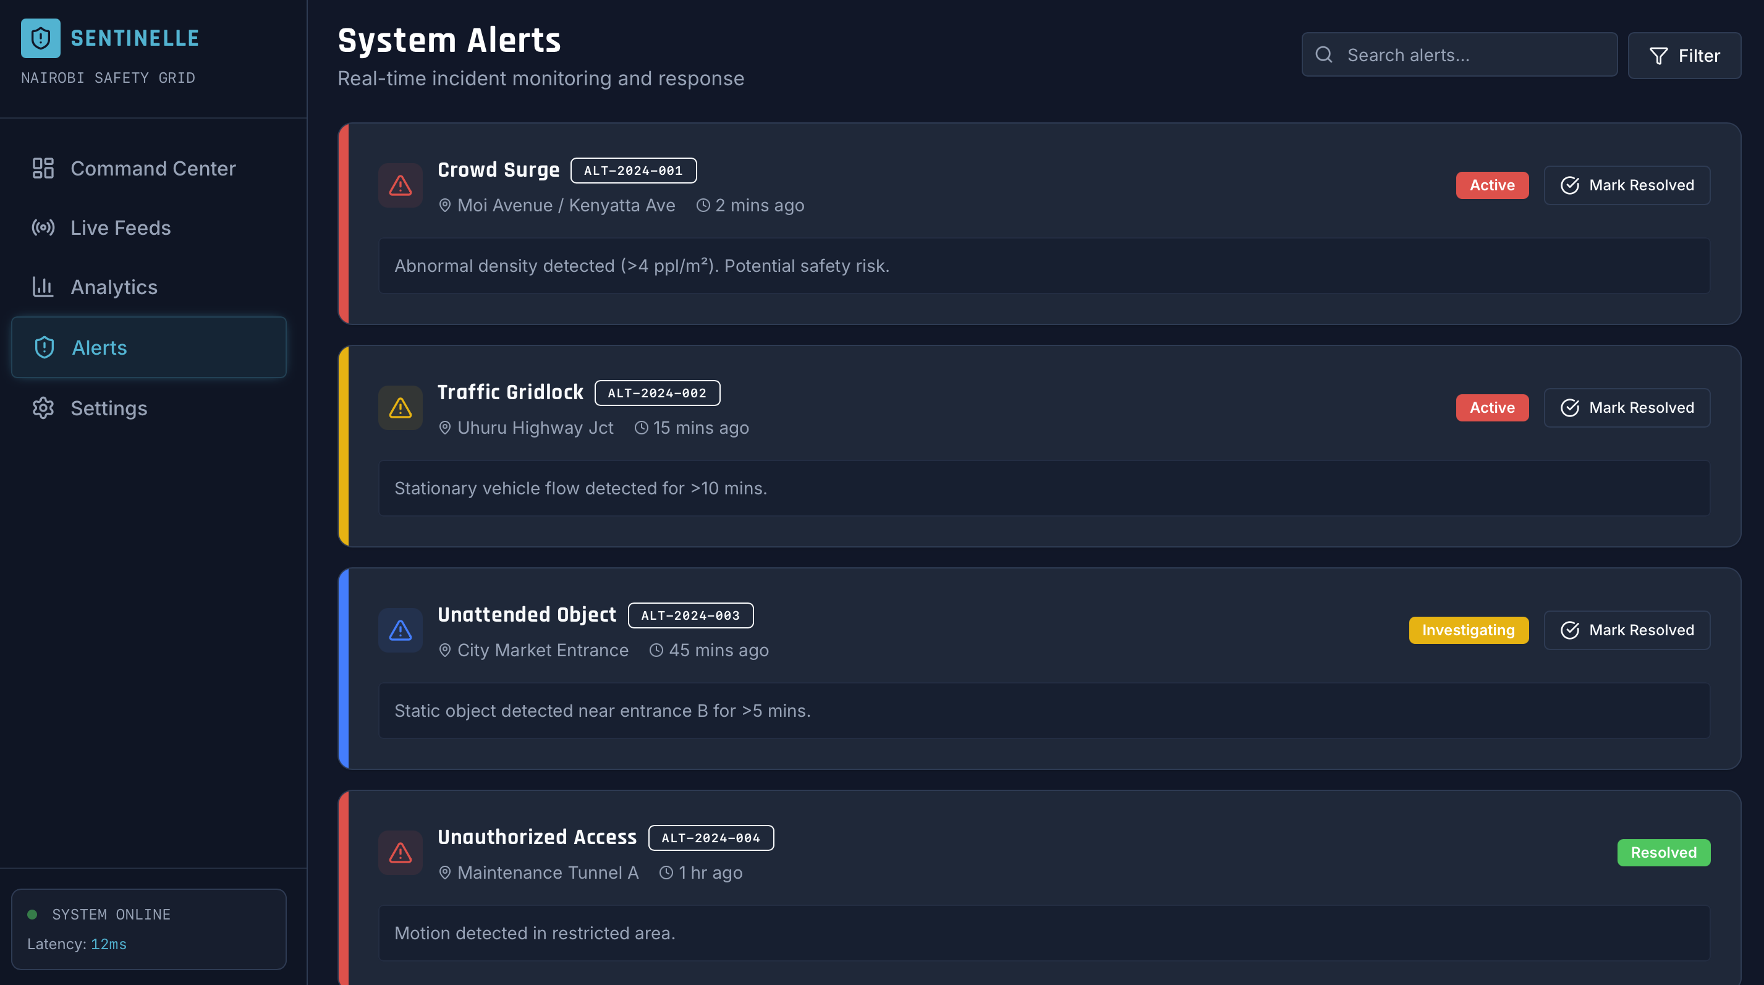

**reports.json**

{

"video": "simulated_input.mp4",

"processed_frames": 50,

"total_people_observations": 0,

"total_vehicle_observations": 0,

"hotspots": [],

"recommendations": [

"Increase patrol presence and lighting in identified hotspots (grid cells with high people counts).",

"Install time-limited parking restrictions and signage at bus_stop / market areas; enforce to reduce illegal parking.",

"Deploy crowd management protocols (additional personnel, temporary barriers) during peak times identified by spikes in crowd alerts.",

"Use real-time alerts to dispatch response teams for loitering and stationary vehicles, and integrate with local traffic enforcement.",

"Complement camera analytics with anonymization (blurring faces) and data governance policies to protect privacy."

]

}

**annotated.mp4**

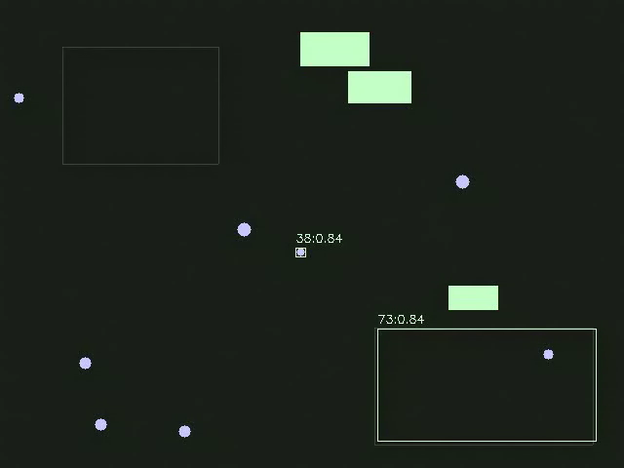

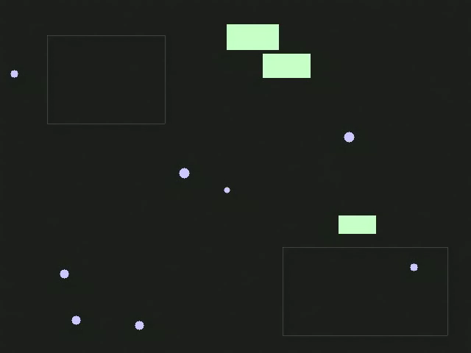**simulated.mp4**

**Code:**

import argparse

import cv2

import numpy as np

import time

import os

import csv

import json

from collections import deque, defaultdict

import torch

import torchvision

from torchvision import transforms

import pandas as pd

"""

Video analytics pipeline for public safety

"""

try:

TORCH_AVAILABLE = True

except Exception:

TORCH_AVAILABLE = False

# -------------------------

# Simulation

# -------------------------

def simulate_video(path="simulated.mp4", n_frames=600, size=(640, 480), fps=20):

"""Generate a synthetic public-space video with moving rectangles."""

w, h = size

fourcc = cv2.VideoWriter_fourcc(*"mp4v")

out = cv2.VideoWriter(path, fourcc, fps, (w, h))

rng = np.random.RandomState(42)

people = []

vehicles = []

# spawn some initial actors

for _ in range(8):

people.append({

"pos": np.array([rng.randint(0, w), rng.randint(0, h)]).astype(float),

"vel": (rng.rand(2) - 0.5) * 4,

"size": rng.randint(8, 16),

"color": (255, 200, 200)

})

for _ in range(3):

vehicles.append({

"pos": np.array([rng.randint(0, w), rng.randint(0, h)]).astype(float),

"vel": (rng.rand(2) - 0.5) * 6,

"size": rng.randint(24, 40),

"color": (200, 255, 200)

})

# define some zones (x1,y1,x2,y2) for "no-parking" or bus stops

zones = {

"market": (int(0.1*w), int(0.1*h), int(0.35*w), int(0.35*h)),

"bus_stop": (int(0.6*w), int(0.7*h), int(0.95*w), int(0.95*h)),

}

for f in range(n_frames):

frame = np.full((h, w, 3), 30, dtype=np.uint8)

# draw zones lightly

for name, (x1,y1,x2,y2) in zones.items():

cv2.rectangle(frame, (x1,y1), (x2,y2), (60,60,80), 1)

# spawn occasional new people

if rng.rand() < 0.03:

people.append({

"pos": np.array([rng.randint(0, w), rng.randint(0, h)]).astype(float),

"vel": (rng.rand(2) - 0.5) * 4,

"size": rng.randint(8, 16),

"color": (255, 200, 200)

})

# update and draw people

for p in people:

p["pos"] += p["vel"]

# bounce at borders

for i in (0,1):

if p["pos"][i] < 0 or p["pos"][i] >= (w if i==0 else h):

p["vel"][i] *= -1

p["pos"][i] = np.clip(p["pos"][i], 0, (w-1) if i==0 else (h-1))

cx, cy = int(p["pos"][0]), int(p["pos"][1])

r = int(p["size"]/2)

cv2.circle(frame, (cx, cy), r, p["color"], -1)

# update and draw vehicles

for v in vehicles:

# occasional stop in bus stop zone to simulate parking

if np.random.rand() < 0.002:

v["vel"] = np.array([0.0, 0.0])

# random resume

if np.random.rand() < 0.01 and np.linalg.norm(v["vel"]) < 0.5:

v["vel"] = (rng.rand(2) - 0.5) * 6

v["pos"] += v["vel"]

for i in (0,1):

limit = w if i==0 else h

if v["pos"][i] < 0 or v["pos"][i] >= limit:

v["vel"][i] *= -1

v["pos"][i] = np.clip(v["pos"][i], 0, limit-1)

cx, cy = int(v["pos"][0]), int(v["pos"][1])

s = int(v["size"])

cv2.rectangle(frame, (cx-s, cy-s//2), (cx+s, cy+s//2), v["color"], -1)

# add synthetic background motion (e.g., trees shimmer)

noise = (rng.rand(h, w) * 2).astype(np.uint8)

frame = cv2.add(frame, np.stack([noise]*3, axis=2))

out.write(frame)

out.release()

return path

# -------------------------

# Detector helpers

# -------------------------

COCO_PERSON_ID = 1

COCO_VEHICLE_IDS = {3, 6, 8} # car, bus, truck (approx)

COCO_LABELS = None

def load_coco_labels():

# short COCO label list (index starts at 1)

labels = {1: "person", 2:"bicycle",3:"car",4:"motorcycle",5:"airplane",6:"bus",

7:"train",8:"truck",9:"boat",10:"traffic light"}

return labels

def load_torch_detector(device="cpu"):

global COCO_LABELS

COCO_LABELS = load_coco_labels()

if not TORCH_AVAILABLE:

return None, device

model = torchvision.models.detection.fasterrcnn_resnet50_fpn(pretrained=True)

model.to(device)

model.eval()

transform = transforms.Compose([

transforms.ToTensor()

])

return (model, transform), device

# -------------------------

# Simple centroid tracker

# -------------------------

class CentroidTracker:

def __init__(self, max_distance=50, max_lost=30):

self.next_id = 1

self.objects = dict() # id -> (centroid, last_seen_frame, trace deque)

self.max_distance = max_distance

self.max_lost = max_lost

def update(self, detections, frame_idx):

# detections: list of (x, y) centroids

assigned = set()

new_objects = dict()

# simple greedy assignment

for oid, (centroid, last_seen, trace) in list(self.objects.items()):

best = None

best_d = None

for i, c in enumerate(detections):

if i in assigned:

continue

d = np.linalg.norm(np.array(centroid) - np.array(c))

if d <= self.max_distance and (best is None or d < best_d):

best = i

best_d = d

if best is not None:

c = detections[best]

trace.append(c)

if len(trace) > 64:

trace.popleft()

new_objects[oid] = (c, frame_idx, trace)

assigned.add(best)

else:

# not matched: keep but mark lost

if frame_idx - last_seen <= self.max_lost:

new_objects[oid] = (centroid, last_seen, trace)

# else drop

# add unmatched detections

for i, c in enumerate(detections):

if i in assigned:

continue

oid = self.next_id

self.next_id += 1

dq = deque([c], maxlen=64)

new_objects[oid] = (c, frame_idx, dq)

self.objects = new_objects

return self.objects

# -------------------------

# Processing pipeline

# -------------------------

def process_video(input_path, output_path="annotated.mp4", log_path="events.csv", report_path="report.json",

device="cpu", run_detector=True, detect_every=1):

# try to load detector

detector, device = None, device

if run_detector:

det_res = load_torch_detector(device=device)

if det_res[0] is None:

detector = None

print("Torch unavailable: falling back to HOG people detector.")

else:

detector = det_res[0]

else:

detector = None

cap = cv2.VideoCapture(input_path)

if not cap.isOpened():

raise FileNotFoundError(f"Cannot open video {input_path}")

fps = cap.get(cv2.CAP_PROP_FPS) or 20.0

w = int(cap.get(cv2.CAP_PROP_FRAME_WIDTH))

h = int(cap.get(cv2.CAP_PROP_FRAME_HEIGHT))

fourcc = cv2.VideoWriter_fourcc(*"mp4v")

out = cv2.VideoWriter(output_path, fourcc, fps, (w,h))

# background subtractor

backSub = cv2.createBackgroundSubtractorMOG2(history=500, detectShadows=True)

# tracker for people and vehicles (separate)

person_tracker = CentroidTracker(max_distance=60, max_lost=int(fps*3))

vehicle_tracker = CentroidTracker(max_distance=80, max_lost=int(fps*10))

# prepare HOG fallback

hog = None

if detector is None:

hog = cv2.HOGDescriptor()

hog.setSVMDetector(cv2.HOGDescriptor_getDefaultPeopleDetector())

frame_idx = 0

logs = []

hotspots = defaultdict(int)

while True:

ret, frame = cap.read()

if not ret:

break

frame_idx += 1

t0 = time.time()

fgmask = backSub.apply(frame)

# morphological cleanup

fg = cv2.medianBlur(fgmask, 5)

_, fg = cv2.threshold(fg, 200, 255, cv2.THRESH_BINARY)

fg = cv2.morphologyEx(fg, cv2.MORPH_CLOSE, np.ones((5,5), np.uint8))

people_centroids = []

vehicle_centroids = []

detections_out = []

if detector and frame_idx % detect_every == 0:

model, transform = detector

img_t = transform(frame).to(device)

with torch.no_grad():

preds = model([img_t])[0]

boxes = preds["boxes"].cpu().numpy()

labels = preds["labels"].cpu().numpy()

scores = preds["scores"].cpu().numpy()

for box, label, score in zip(boxes, labels, scores):

if score < 0.6:

continue

x1,y1,x2,y2 = box.astype(int)

cx = int((x1+x2)/2); cy = int((y1+y2)/2)

lbl = COCO_LABELS.get(int(label), str(int(label)))

detections_out.append((lbl, score, (x1,y1,x2,y2)))

if int(label) == COCO_PERSON_ID:

people_centroids.append((cx, cy))

if int(label) in COCO_VEHICLE_IDS:

vehicle_centroids.append((cx, cy))

else:

# fallback: use background segments and simple contours; detect people via HOG

contours, _ = cv2.findContours(fg, cv2.RETR_EXTERNAL, cv2.CHAIN_APPROX_SIMPLE)

for cnt in contours:

x,y,ww,hh = cv2.boundingRect(cnt)

area = ww*hh

if area < 200: continue

cx = x+ww//2; cy = y+hh//2

# classify by size heuristics

if hh < 30:

people_centroids.append((cx, cy))

detections_out.append(("person", 0.5, (x,y,x+ww,y+hh)))

else:

vehicle_centroids.append((cx, cy))

detections_out.append(("vehicle", 0.5, (x,y,x+ww,y+hh)))

# HOG refine people (optional)

if hog is not None:

rects, weights = hog.detectMultiScale(frame, winStride=(8,8), padding=(8,8), scale=1.05)

for (x,y,ww,hh), wgt in zip(rects, weights):

if wgt < 0.6: continue

cx = int(x+ww/2); cy = int(y+hh/2)

people_centroids.append((cx, cy))

detections_out.append(("person_hog", float(wgt), (x,y,x+ww,y+hh)))

# update trackers

persons = person_tracker.update(people_centroids, frame_idx)

vehicles = vehicle_tracker.update(vehicle_centroids, frame_idx)

alerts = []

# detect loitering: person whose trace is within small radius for long time

for pid, (centroid, last_seen, trace) in persons.items():

if len(trace) >= int(fps*10): # been tracked for >10s

pts = np.array(trace)

dmax = np.max(np.linalg.norm(pts - pts[0], axis=1))

if dmax < 20:

alerts.append({"type":"loitering","id":pid,"pos":centroid})

# annotate

cv2.putText(frame, f"LOITER-{pid}", (centroid[0]+5, centroid[1]-5),

cv2.FONT_HERSHEY_SIMPLEX, 0.5, (0,0,255), 2)

# stationary vehicle detection -> possible illegal parking

for vid, (centroid, last_seen, trace) in vehicles.items():

if len(trace) >= int(fps*8):

pts = np.array(trace)

dmax = np.max(np.linalg.norm(pts - pts[0], axis=1))

if dmax < 10:

alerts.append({"type":"illegal_parking","id":vid,"pos":centroid})

cv2.putText(frame, f"PARK-{vid}", (centroid[0]+5, centroid[1]-5),

cv2.FONT_HERSHEY_SIMPLEX, 0.5, (0,165,255), 2)

# crowd detection: many people in small area

if len(people_centroids) >= 6:

# compute pairwise density

pts = np.array(people_centroids)

if pts.shape[0] >= 6:

# compute bounding box area

x_min, y_min = pts.min(axis=0)

x_max, y_max = pts.max(axis=0)

area = (x_max - x_min + 1) * (y_max - y_min + 1)

density = len(people_centroids) / max(area, 1)

if density > 0.002: # heuristic density threshold

alerts.append({"type":"crowd", "count": len(people_centroids), "bbox": [int(x_min),int(y_min),int(x_max),int(y_max)]})

cv2.rectangle(frame, (int(x_min),int(y_min)), (int(x_max),int(y_max)), (0,0,255), 2)

cv2.putText(frame, f"CROWD {len(people_centroids)}", (int(x_min), int(y_min)-8),

cv2.FONT_HERSHEY_SIMPLEX, 0.8, (0,0,255), 2)

# annotate detections

for lbl, score, box in detections_out:

x1,y1,x2,y2 = box

color = (200,200,255) if "person" in lbl else (200,255,200)

cv2.rectangle(frame, (x1,y1), (x2,y2), color, 1)

cv2.putText(frame, f"{lbl}:{score:.2f}", (x1, max(0,y1-6)),

cv2.FONT_HERSHEY_SIMPLEX, 0.4, color, 1)

# annotate trackers

for pid, (centroid, last_seen, trace) in persons.items():

cv2.circle(frame, (int(centroid[0]), int(centroid[1])), 3, (255,0,0), -1)

cv2.putText(frame, f"P{pid}", (int(centroid[0])+4, int(centroid[1])+4),

cv2.FONT_HERSHEY_SIMPLEX, 0.4, (255,0,0), 1)

for vid, (centroid, last_seen, trace) in vehicles.items():

cv2.circle(frame, (int(centroid[0]), int(centroid[1])), 3, (0,255,0), -1)

cv2.putText(frame, f"V{vid}", (int(centroid[0])+4, int(centroid[1])+4),

cv2.FONT_HERSHEY_SIMPLEX, 0.4, (0,255,0), 1)

# write frame

out.write(frame)

# logging

ts = frame_idx / fps

entry = {

"frame": frame_idx,

"time_s": round(ts,2),

"people_count": len(people_centroids),

"vehicle_count": len(vehicle_centroids),

"alerts": alerts

}

logs.append(entry)

# hotspot accumulation by simple grid

for c in people_centroids:

gx = int(c[0] / (w/10))

gy = int(c[1] / (h/10))

hotspots[(gx,gy)] += 1

if frame_idx % int(fps*10) == 0:

print(f"[{frame_idx}] people:{len(people_centroids)} vehicles:{len(vehicle_centroids)} alerts:{len(alerts)} dt:{time.time()-t0:.2f}s")

cap.release()

out.release()

# save logs

df = pd.DataFrame([

{"frame": e["frame"], "time_s": e["time_s"], "people_count": e["people_count"],

"vehicle_count": e["vehicle_count"], "alerts": json.dumps(e["alerts"])}

for e in logs

])

df.to_csv(log_path, index=False)

# summarize hotspots top-k

hot = sorted(hotspots.items(), key=lambda x: -x[1])[:8]

hot_zones = []

for (gx,gy), cnt in hot:

hot_zones.append({"grid": [int(gx),int(gy)], "count": int(cnt)})

# generate simple report with actionable strategies

report = {

"video": os.path.basename(input_path),

"processed_frames": frame_idx,

"total_people_observations": int(sum([e["people_count"] for e in logs])),

"total_vehicle_observations": int(sum([e["vehicle_count"] for e in logs])),

"hotspots": hot_zones,

"recommendations": [

"Increase patrol presence and lighting in identified hotspots (grid cells with high people counts).",

"Install time-limited parking restrictions and signage at bus_stop / market areas; enforce to reduce illegal parking.",

"Deploy crowd management protocols (additional personnel, temporary barriers) during peak times identified by spikes in crowd alerts.",

"Use real-time alerts to dispatch response teams for loitering and stationary vehicles, and integrate with local traffic enforcement.",

"Complement camera analytics with anonymization (blurring faces) and data governance policies to protect privacy."

]

}

with open(report_path, "w") as f:

json.dump(report, f, indent=2)

print(f"Processing complete. Annotated video: {output_path}, logs: {log_path}, report: {report_path}")

return output_path, log_path, report_path

# -------------------------

# CLI

# -------------------------

def main():

p = argparse.ArgumentParser(description="Video analytics prototype for urban public safety.")

p.add_argument("--simulate", action="store_true", help="Create a simulated video and process it.")

p.add_argument("--input", type=str, help="Input video path.")

p.add_argument("--out", type=str, default="annotated.mp4", help="Annotated output video path.")

p.add_argument("--log", type=str, default="events.csv", help="CSV log output.")

p.add_argument("--report", type=str, default="report.json", help="JSON report output.")

p.add_argument("--device", type=str, default="cpu", help="torch device (cpu or cuda).")

p.add_argument("--frames", type=int, default=600, help="Frames to simulate when --simulate.")

args = p.parse_args()

if args.simulate:

sim_path = "simulated_input.mp4"

print("Generating simulated video:", sim_path)

simulate_video(path=sim_path, n_frames=args.frames)

input_path = sim_path

else:

if not args.input:

p.print_help()

return

input_path = args.input

# try to use GPU if requested

device = args.device

if device != "cpu" and TORCH_AVAILABLE and torch.cuda.is_available():

device = "cuda"

else:

device = "cpu"

process_video(input_path, output_path=args.out, log_path=args.log, report_path=args.report, device=device)

if __name__ == "__main__":

main()